## MARS

## MARS (*MIPS Assembler and Runtime Simulator* is a lightweight interactive development environment (IDE) for programming in MIPS assembly language, intended for educational-level use with Patterson and Hennessy's Computer Organization and Design.

* An IDE for MIPS Assembly Language Programming
* GUI with point-and-click control and integrated editor
* Easily editable register and memory values
* Display values in hexadecimal or decimal

Instructions

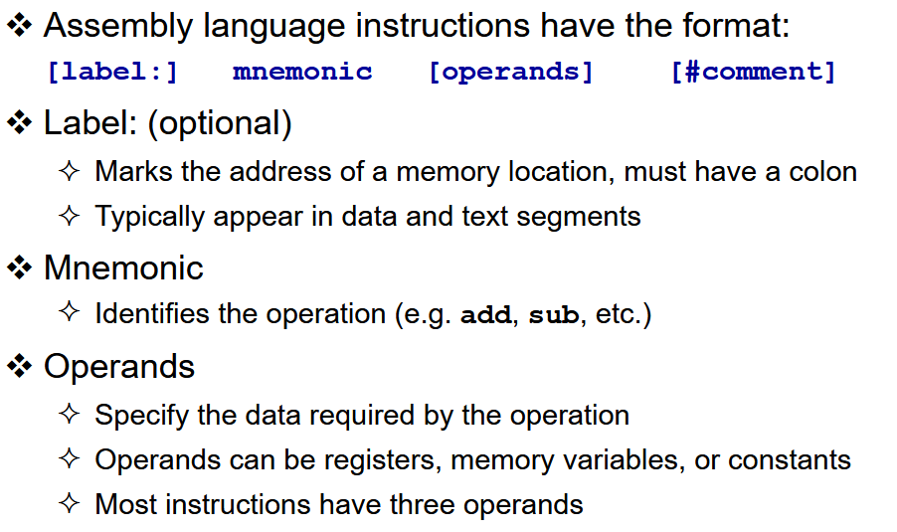



addiu→add immediate unsigne

Comments

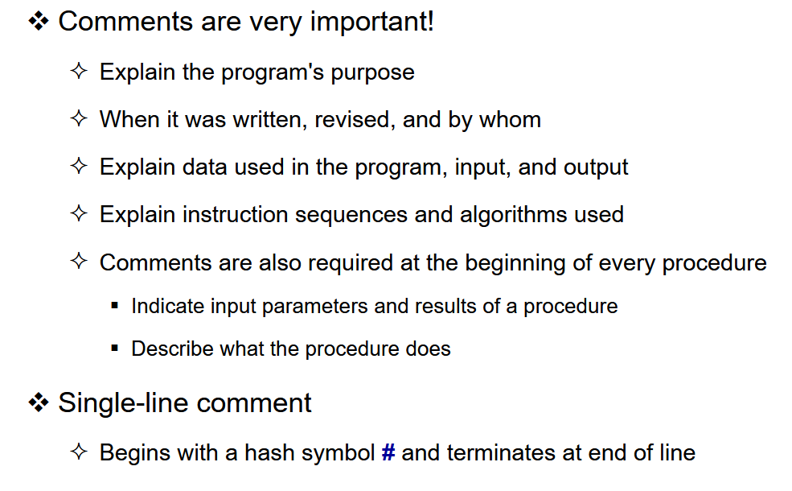

Program Template

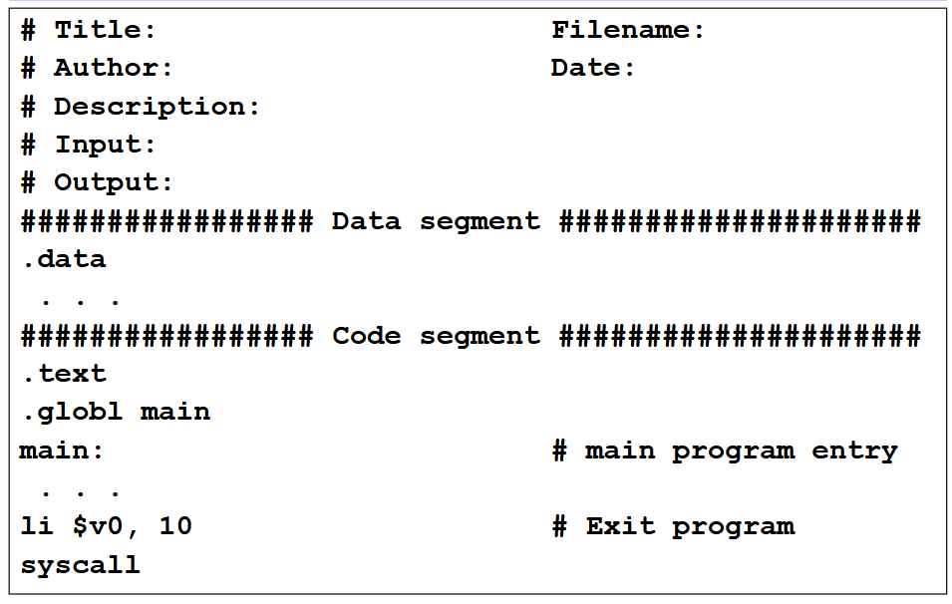



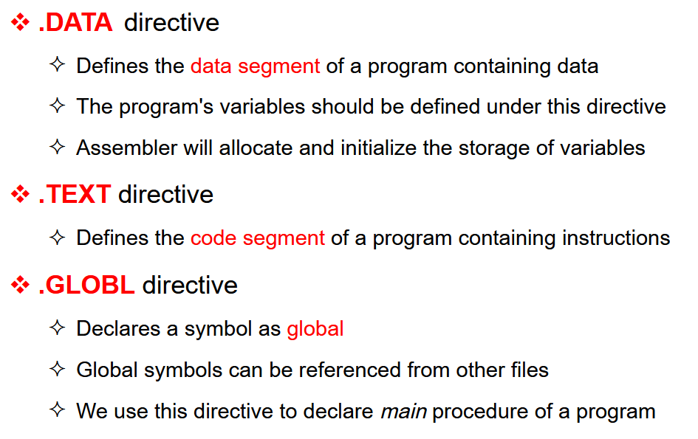



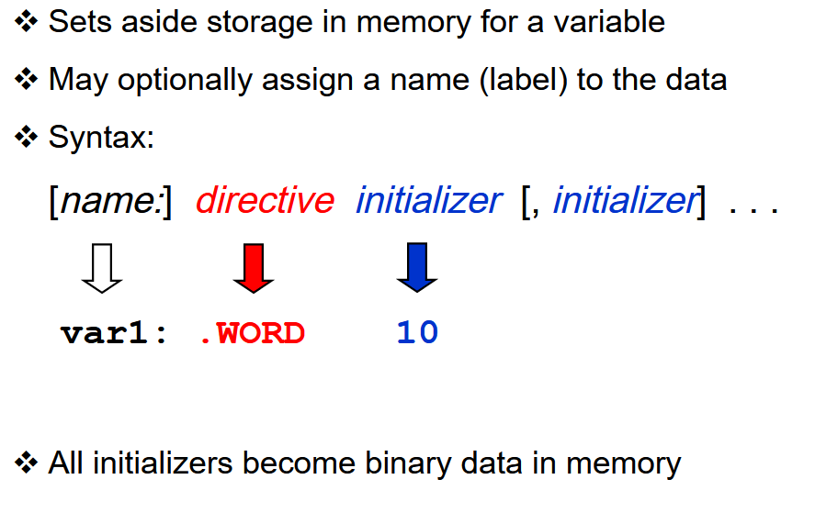



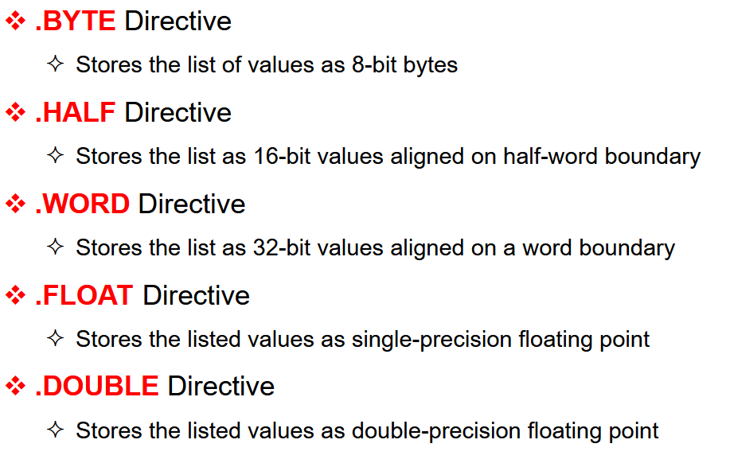

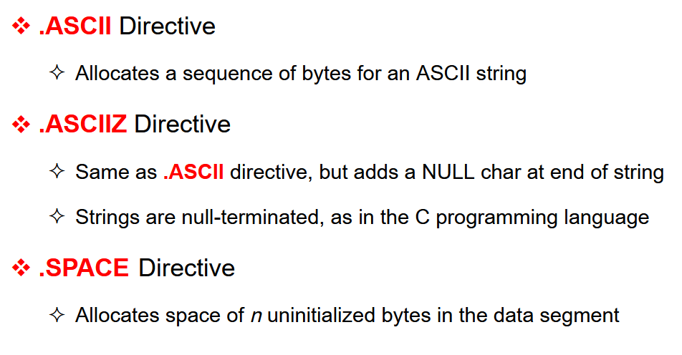



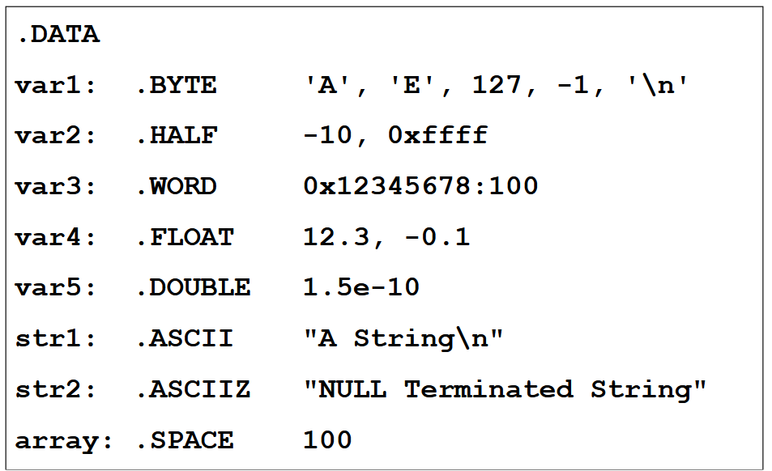



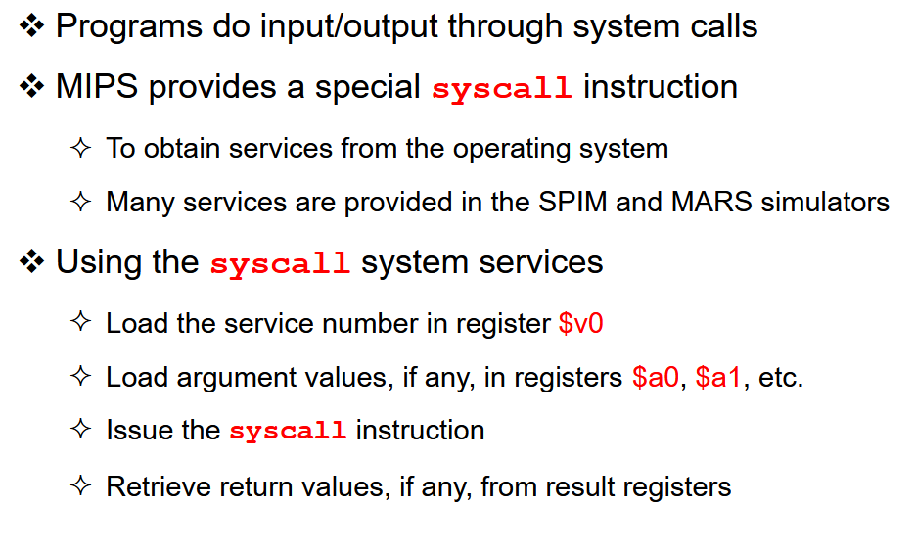



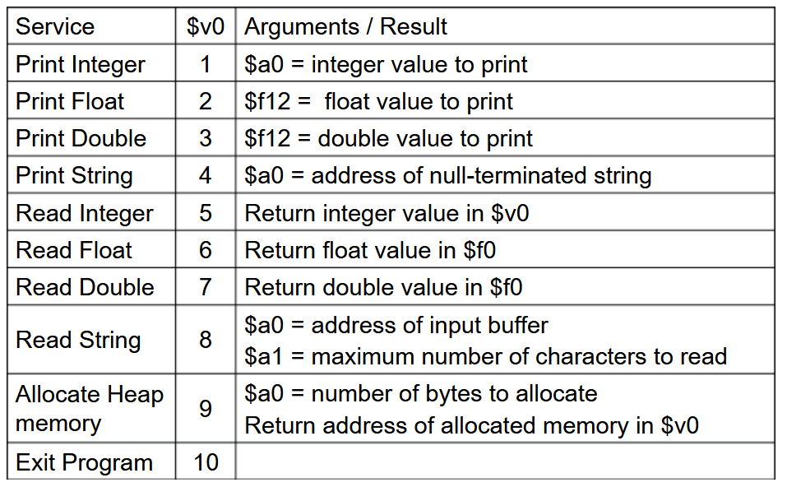



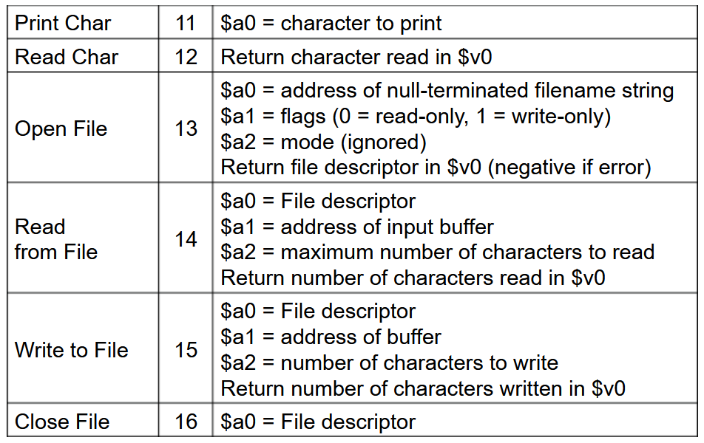



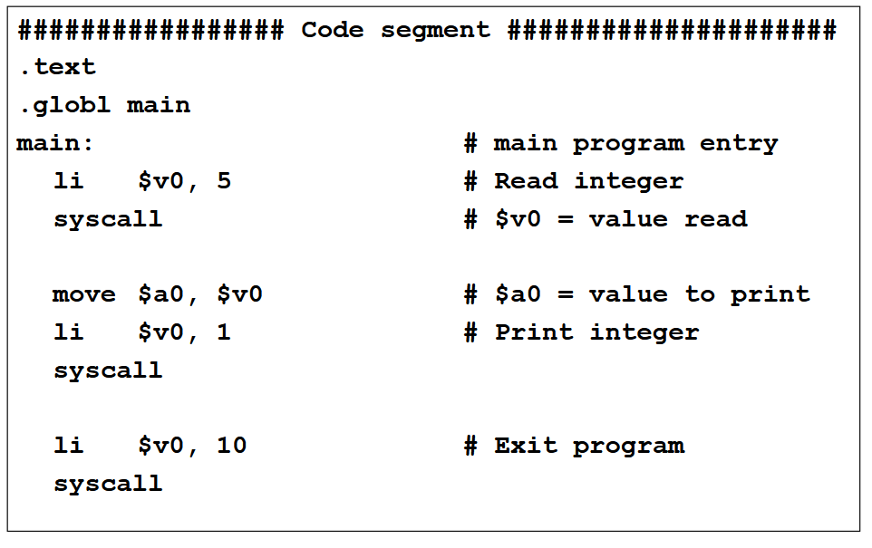

**Load Immediate** (li) The **li** pseudo instruction loads an immediate value into a register.



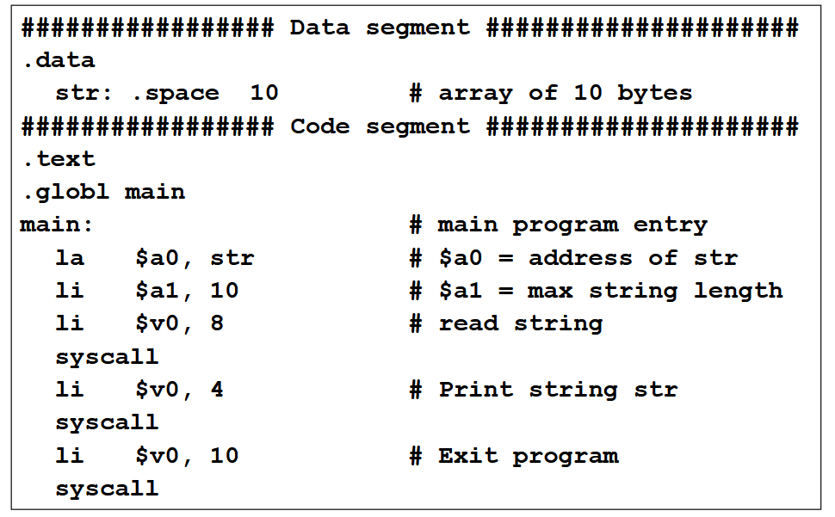

Problem 3

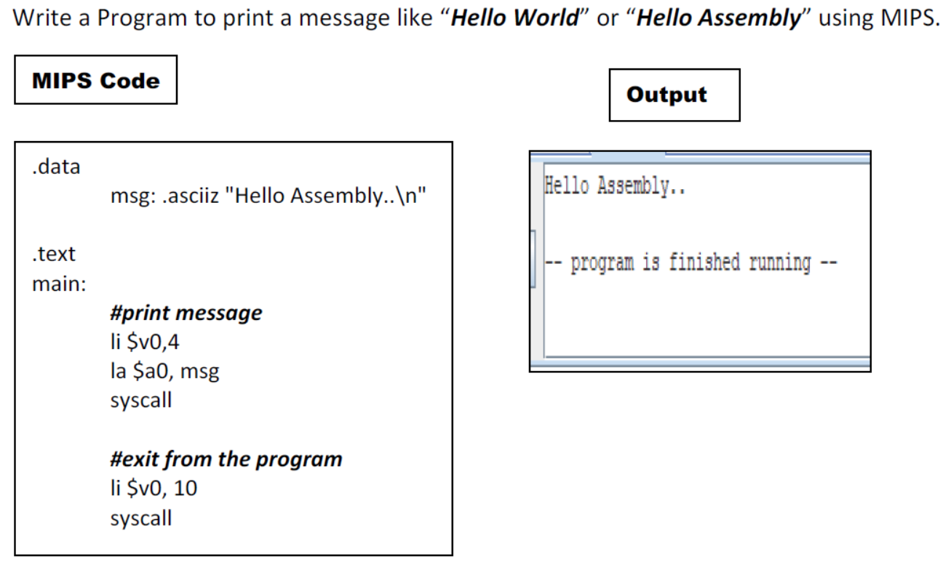

Problem 4

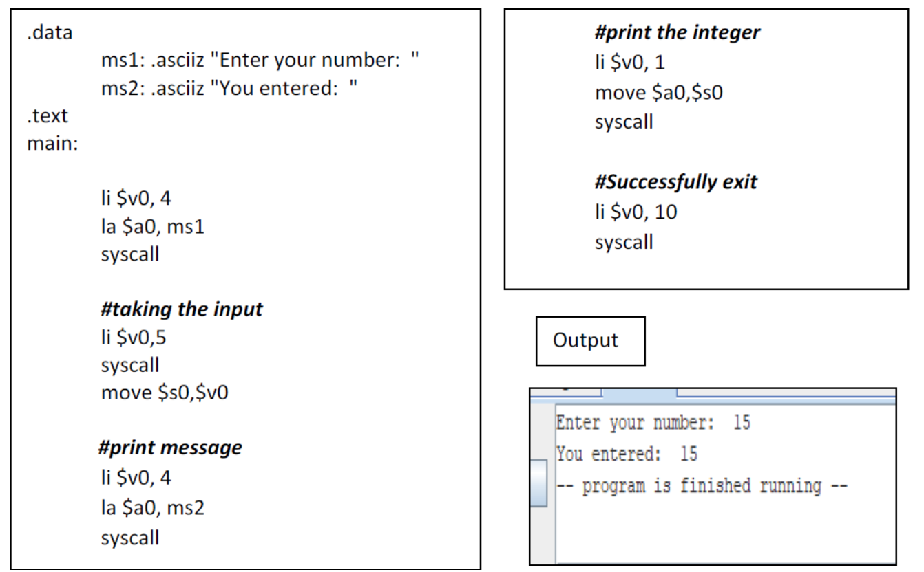

Problem 5

Write a program to check the equality of two numbers.

